**HelpDesk Ticket Management System (HTMS)**

Application Sign-Up & Users Documentation

1. **Introduction.**This documentation provides clear and formal instructions for signing up for the HelpDesk Ticket Management System (HTMS) application. HTMS is a powerful ticketing system that allows users to raise tickets for various IT-related issues and track their progress until resolution. By following the steps outlined below, users will be able to create an account and access the application's features, enabling them to raise tickets and track their progress seamlessly.

The HTMS application is designed to streamline the IT support process and ensure efficient issue resolution. Whether you need assistance with software problems, hardware malfunctions, or any other IT-related issues, the HTMS application is your go-to platform for requesting help and staying informed about the progress of your tickets.

This documentation aims to provide comprehensive guidance to ensure a smooth sign-up process, allowing users to quickly take advantage of the features and benefits offered by the HTMS application. If you have any questions or encounter difficulties during the sign-up process, our IT Department is readily available to assist you. Please refer to the contact information provided in Section 2 for further assistance.

1. **Contacting IT Department**

If you encounter any I.T related issues, you can contact the IT Department for assistance. Use one of the following methods:

* + Dial 33333 or 33330 from a landline phone to reach the IT Department.

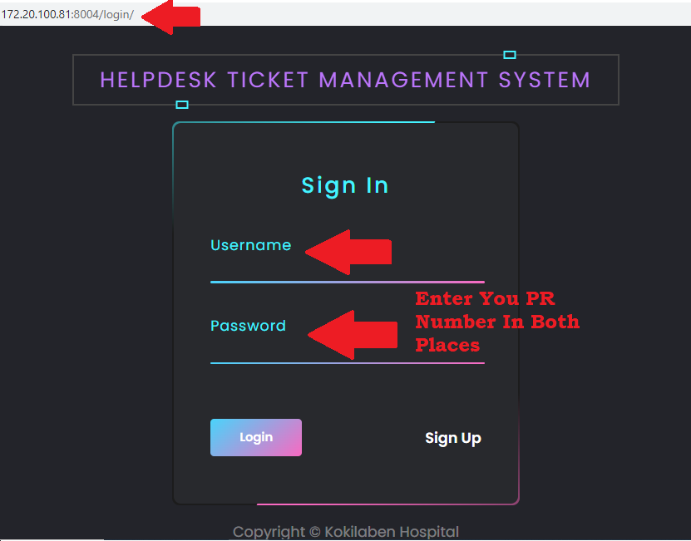

* + Visit our website at <http://172.20.100.81:8004/login/> and raise a support ticket.
  + 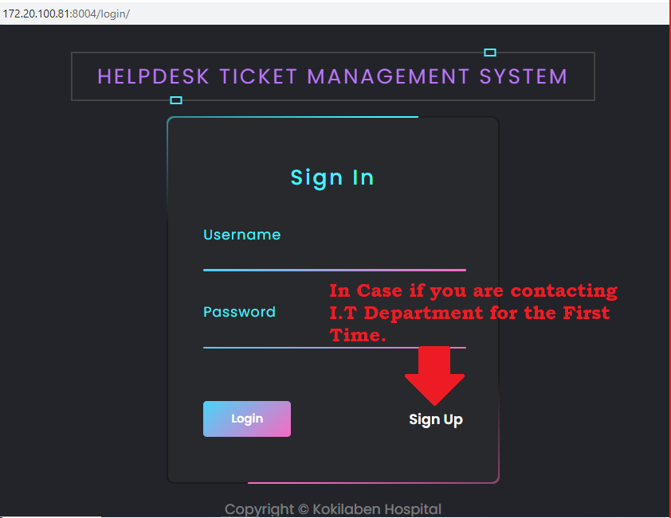On the login page, enter your PR number as your username and password.
  + Whenever you contact I.T Department all you are automatically singed up. But if your contacting I.T Department for the first time then click on the "Sign Up" button on the page. You will be redirected to a sign-up form.

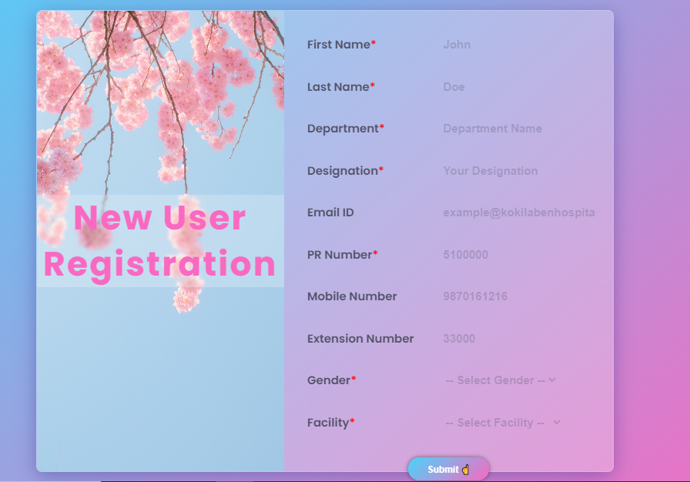

* + Fill in the required details in the sign-up form accurately. Provide the necessary information as requested in the form.
  + After filling up the information, click on the "Submit” The form will be processed, and you will be redirected to the login page.
  + On the login page, enter your PR number as your username and password. Click on the "Login" button.

1. 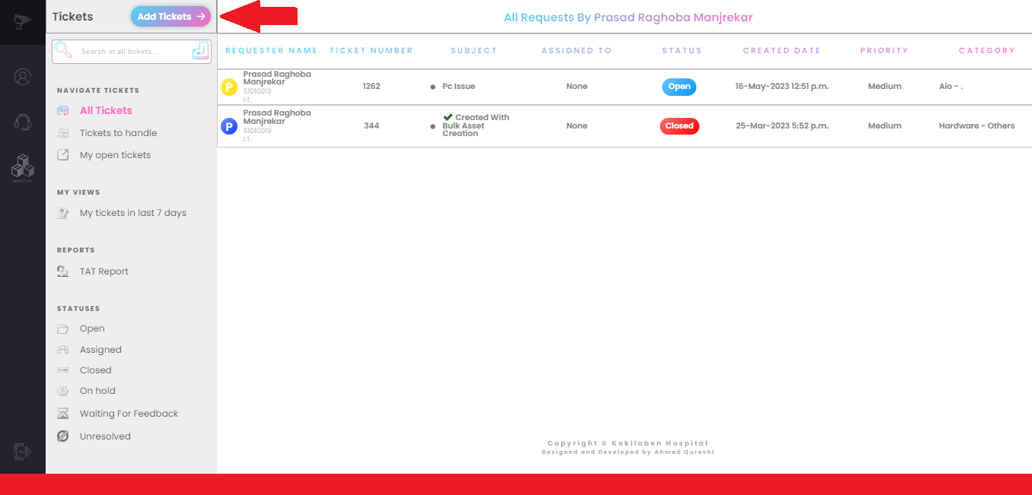User Dashboard Overview Once logged in, you will be redirected to the User Dashboard. The User Dashboard provides an organized view of your tickets, allowing you to easily manage and track their status.
2. Adding a New Ticket To add a new ticket, follow these steps: a. Locate and click on the "Add a Ticket" button.

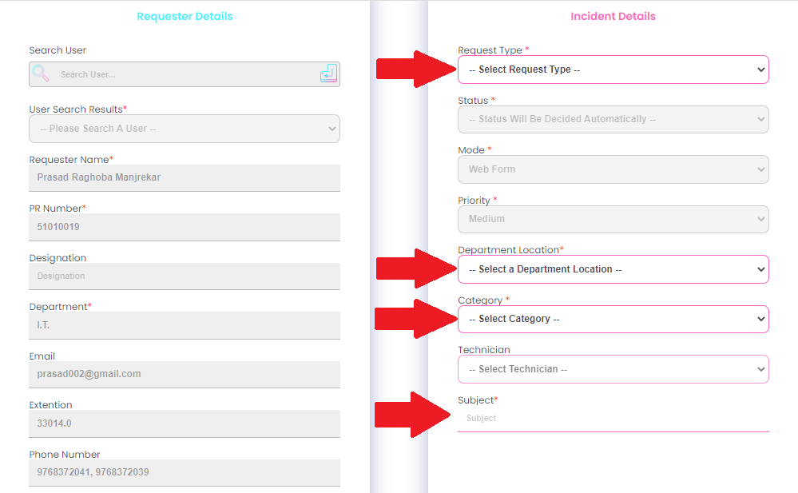

1. A new ticket form will appear, prompting you to provide the necessary details. Most of the fields will be pre-filled for you and wont be editable. Fill in the required fields, as show in the screenshot marked with the red arrow.

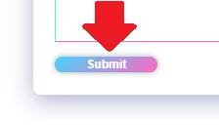

1. Locate and Click on the "Submit" at the bottom of the page .
2. Viewing Existing Tickets On the User Dashboard, you will find a list of all the tickets you have raised. Each ticket will typically display the following information:
   * Ticket ID: A unique identifier for each ticket.
   * Ticket Title: A concise summary of the ticket's subject or issue.
   * Ticket Status: The current status of the ticket (e.g., Open, In Progress, Closed).
   * Ticket Creation Date: The date and time when the ticket was created.

Note: The fields and options available when adding a new ticket may vary depending on the specific system or application you are using.